***Hiring Process Analytics***



Description:

"Developing a comprehensive hiring process analytics solution to optimize recruitment strategies, enhance candidate experience, and streamline decision-making through data-driven insights and performance metrics."

Approach:

1. Download the data set. Open in MS Excel.
2. Find the solutions by performing formulas.
3. Analyse the solution.
4. Note down and make report.

**A. Hiring Analysis:** The hiring process involves bringing new individuals into the organization for various roles.

**Your Task:** Determine the gender distribution of hires. How many males and females have been hired by the company?

-formula used: =COUNTIFS(Sheet1!D:D,"Male",Sheet1!C:C,"Hired")

=COUNTIFS(Sheet1!D:D,"Female",Sheet1!C:C,"Hired")

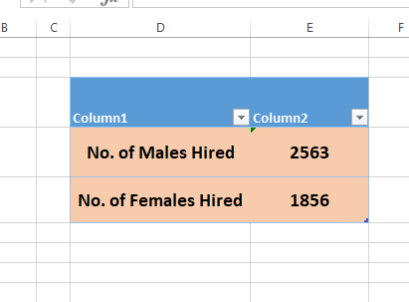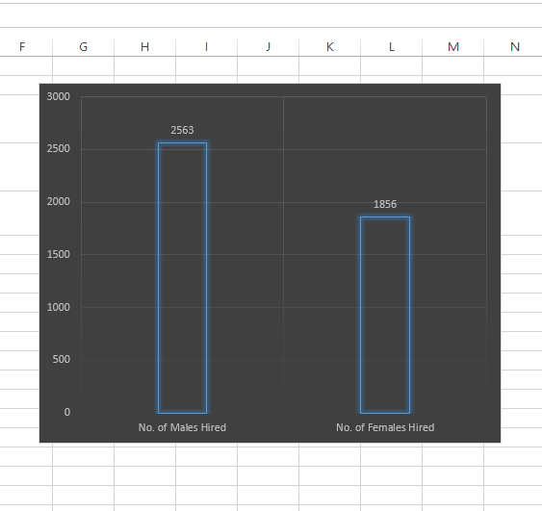

**B. Salary Analysis:** The average salary is calculated by adding up the salaries of a group of employees and then dividing the total by the number of employees.

**Your Task:** What is the average salary offered by this company? Use Excel functions to calculate this.

-formula used: =SUM(Sheet1!G:G)/COUNT(Sheet1!G:G)

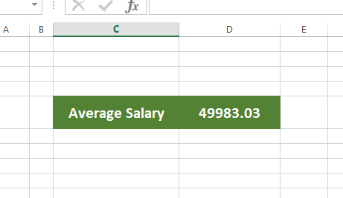

**C. Salary Distribution:** Class intervals represent ranges of values, in this case, salary ranges. The class interval is the difference between the upper and lower limits of a class.

**Your Task:** Create class intervals for the salaries in the company. This will help you understand the salary distribution.

-formula used: =COUNTIFS(Sheet1!G:G,">=0",Sheet1!G:G,"<=10000")…..continue till class interval ends

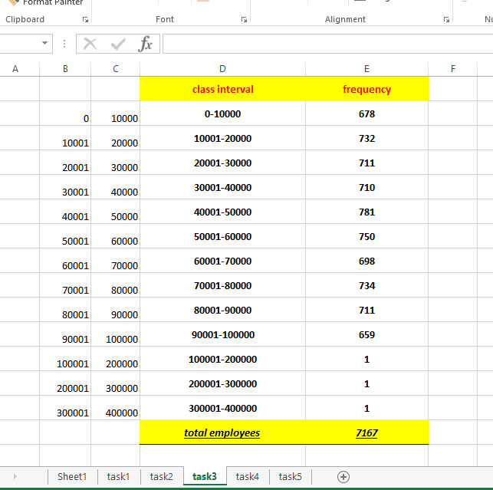

**D. Departmental Analysis:** Visualizing data through charts and plots is a crucial part of data analysis.

**Your Task:** Use a pie chart, bar graph, or any other suitable visualization to show the proportion of people working in different departments.

-formula used:

=COUNTIFS(Sheet1!E:E,"Service Department",Sheet1!C:C,"Hired")

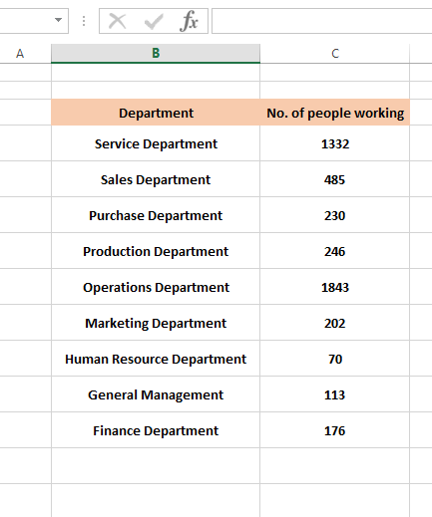

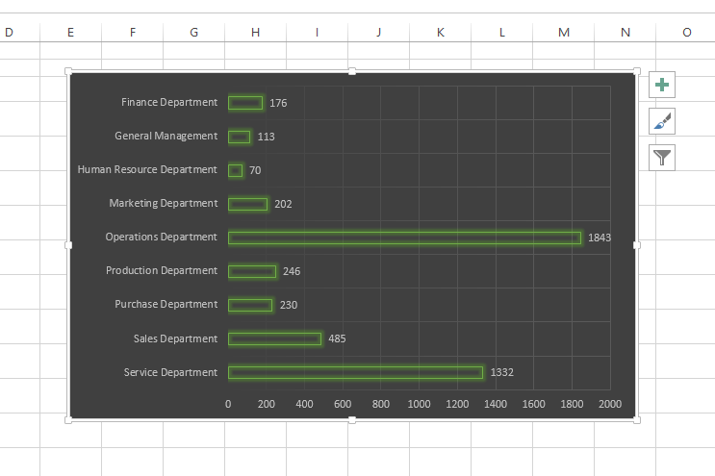

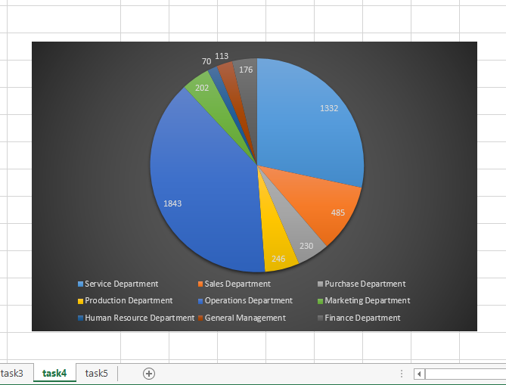

**E. Position Tier Analysis:** Different positions within a company often have different tiers or levels.

**Your Task:** Use a chart or graph to represent the different position tiers within the company. This will help you understand the distribution of positions across different tiers.

-formula used: =COUNTIFS(A:A,"i1",B:B,"Hired")

…..same on all post or tier.

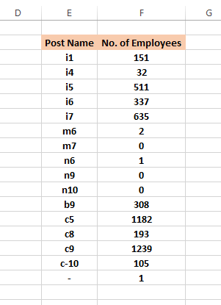

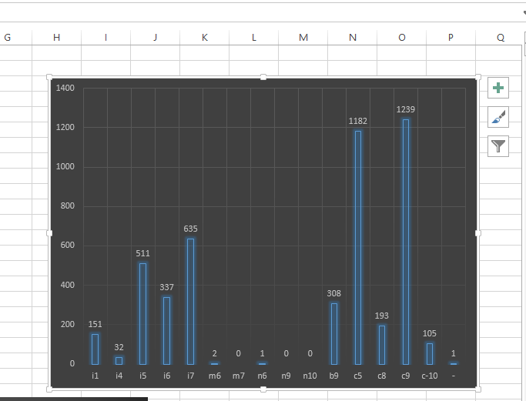

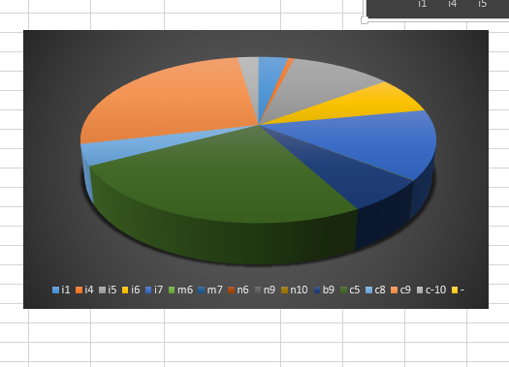

**Result:**

No. of males hired=2563

No. of females hired=1856

Average salary=49983.03

THANKYOU